Documentation:

1. It took me about 3-4 seconds to load the data into S3. The data size is 11.5MB (about 6,865 records).

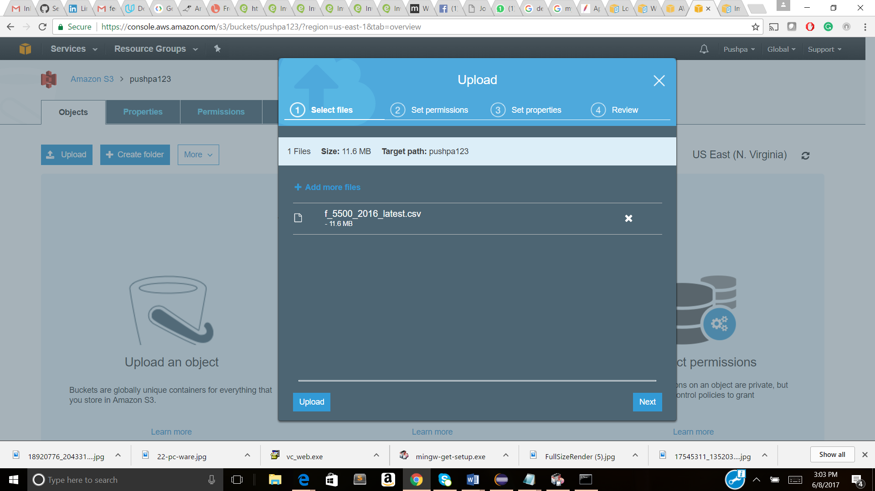

1. (i) Created an API

(ii) Customized the authorized roles and permissions

(iii) Created a Resource

(iv) Created a GET Method to expose the lambda client service

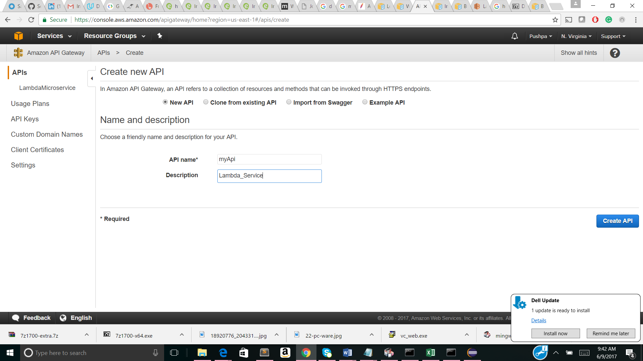

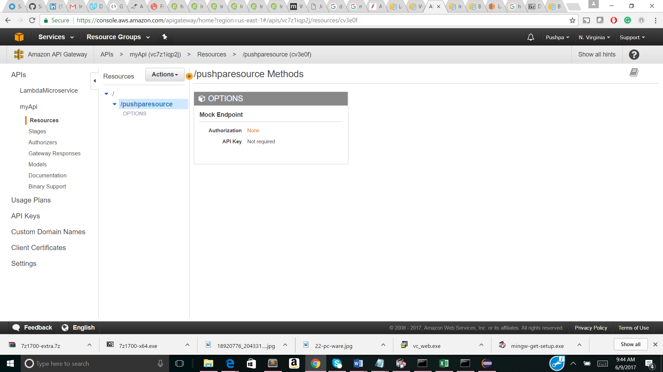

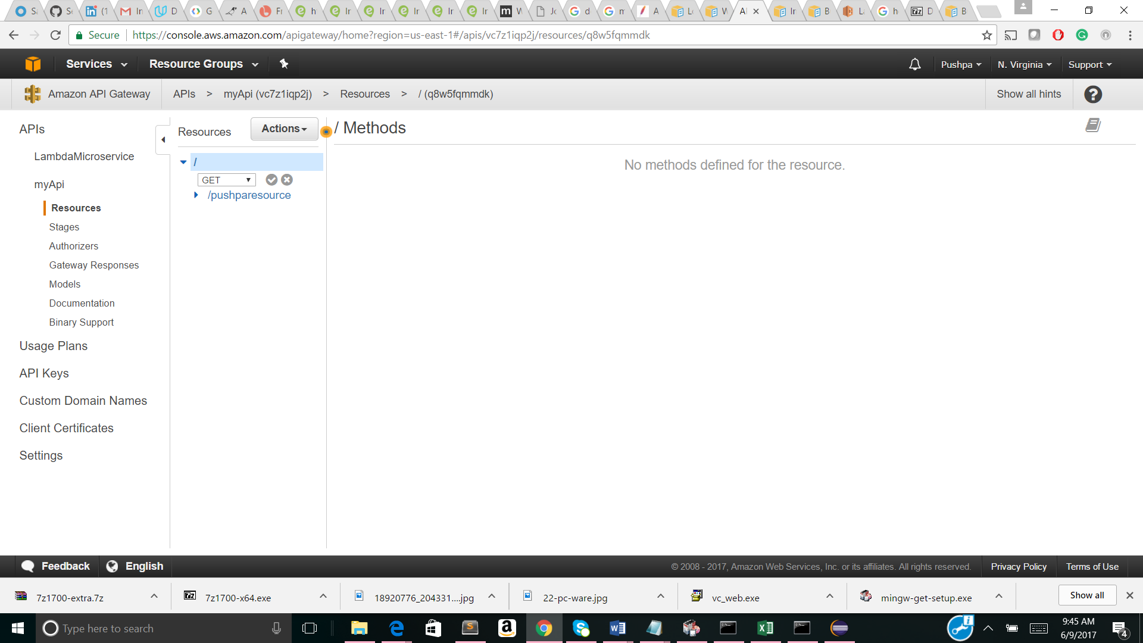

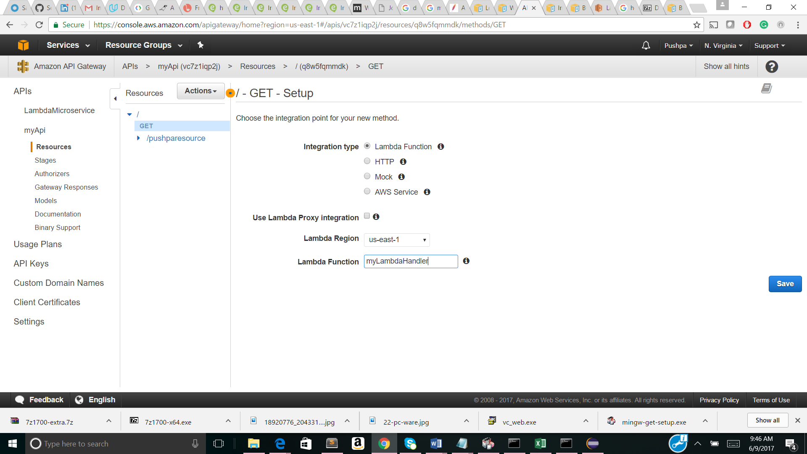

1. (i) Maven project is setup

(ii) Written the test code in Java and tested with the test data provided

(iii) Written the test client Lambda code in Java

(iv) (a)Created a lambda function in python code written in-line : worked

(b)Created a lambda function and tried to upload the java jar/zip file containing the POM.xml and handler.java files.

Difficulties: Uploading of zip file failed in Lambda function. Installed the zip execution software, but didn’t go through due to large file size (recommended 10MB size in Lambda function, but the file is 15KB). Since the direct upload of jar file failed, I have tried storing the files in S3 (tried executing both individual files as well as zip/jar files) and specifying the link in the lambda function creation. Unfortunately, it still didn’t go through.

Pros: The Java code to perform a search function worked. Attaching the eclipse java package (please execute the handler.java class file from a package name: Chettu and check for the results). Similarly lambda client service code, Lambda_service.java is also written.

Concerns: Please help me with uploading my working java code in the Lambda function. It would be of a great help. Seeing all the functionality working making me really happy (learnt a lot while executing this task).

Supporting Screenshots:

